Documentation

|  |  |  |  |
| --- | --- | --- | --- |
| Sn | Name | Year of Study | Role played in the project |
| 1 | Joel Dila | 3 | I participated in the coding of the web service and the backend |
| 2 |  |  | I wrote the test codes for almost every component |
| 3 | Evans Simasiku | 3 | I was responsible for developing the entire front end |
| 4 |  |  | I supported the team leader in the documentation of the software |
| 5 |  |  | Helped in the backend |

**Title of the project**

**CrowdFunding Namibia**

**DESCRIPTION OF THE PROJECT**

The main aim of our crowd funding Namibian website is to empower young entrepreneurs to share and express their innovative ideas without fear of them not being supported or funded, this platform offers a solution to dying innovative ideas or ideas that do not reach their full potential, the crowdfunding Namibia serves as a solution to this inhibiting problem, The crowding Funding Namibia website facilitates The platform facilitates the sharing of images, documents, and videos, supports user registration and login, enables commenting, pledging, idea approval workflows, and ensures a mobile-friendly interface that allows not only entrepreneurs to share their ideas but supporters to view, engage with, and contribute to this ideas as well, this fosters a growth environment where innovation can thrive and receive the financial banking it needs.

**FUNCTIONALITIES PROVIDED BY THE SOFTWARE**

**User Registration & Login:** Allows entrepreneurs and supporters to create accounts and securely log in as their roles that they registered or logged in as

* + Entrepreneur: Can register, post business ideas with supporting files, edit or delete ideas, and track approval status.
  + Supporter (Organization): Can view ideas, comment/ask questions, and pledge support.
  + Admin: Approves or rejects ideas and monitors user activity.

**Idea Submission:** Entrepreneurs can upload details, descriptions, for their projects. And also enables them to edit if they want to make changes to their ideas, even after its added

**Project Browsing:** Supporters can view, ideas and give comments and also to pledge if their interested in the idea

**Funding Support:** Enables supporters to pledge funds to projects.

**Admin Database:** For managing entrepreneur’s ideas and projects, it allows and manages which ideas are fitted to go in the view/explore ideas this ensures unnecessary ideas from being submitted, after the idea is posted by the entrepreneur it first has to be approved by the admin for it to go in the platform

**FLOWCHARTS AND/OR ALGORITHMS**

1. User logs into the platform (this means user enters the website it’s not logging in)
2. User selects get started, which goes to the register and login page prompts user to select role in the registration
3. If entrepreneur role: user fills idea form for his/her ideas details (title, description, funding goal) goes to admin database to be approved
4. If supporter role: it goes in the view ideas where supports can pledge and (comment if it’s there)
5. Ideas stored in the ideas in the database and displayed to supporters

**Diagram**

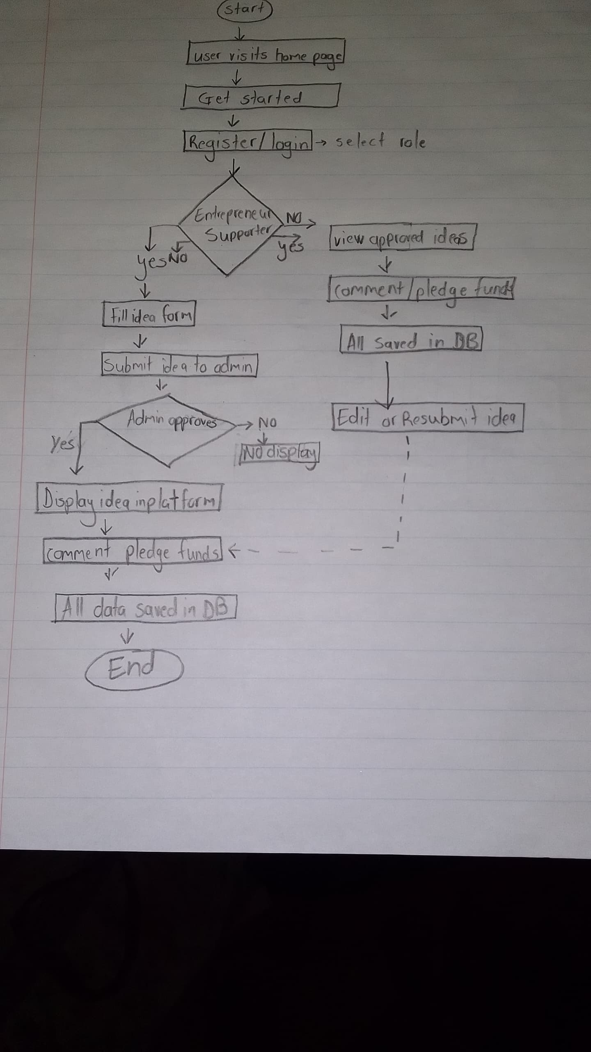

**PROGRAMMING LANGUAGES / TOOLS USED**

* **Frontend:** HTML, bootstrap CSS3, JavaScript(with jQuery)
* **Backend:** PHP
* **Database:** MySQL
* **Tools:** Sublime Text, XAMPP, phpMyAdmin

### ****SOLUTION ARCHITECTURE****

* **Client Side:** Users access the platform through a web browser, interacting with the frontend (HTML, CSS, JavaScript).
* **Server Side:** PHP scripts process requests, interact with the MySQL database, and return responses to the client.
* **Database Layer:** Stores user accounts, project details, and funding records.

**SAMPLE SOURCE CODE SNIPPETS (MAX 2 PAGES)**

Here is the important code like the the register one and login with the php code included and the submission of the entrepreneur form code

**The screenshots**  

### ****SAMPLE SOLUTION / SOFTWARE SCREENSHOTS (MAX 3 PAGES)****

* **Home Page** – Displays get started page and different navigations.
* **Submission Page** – Allows entrepreneurs to enter project details.
* **Supporter Page** – Shows project details and funding options.

**The screenshots**

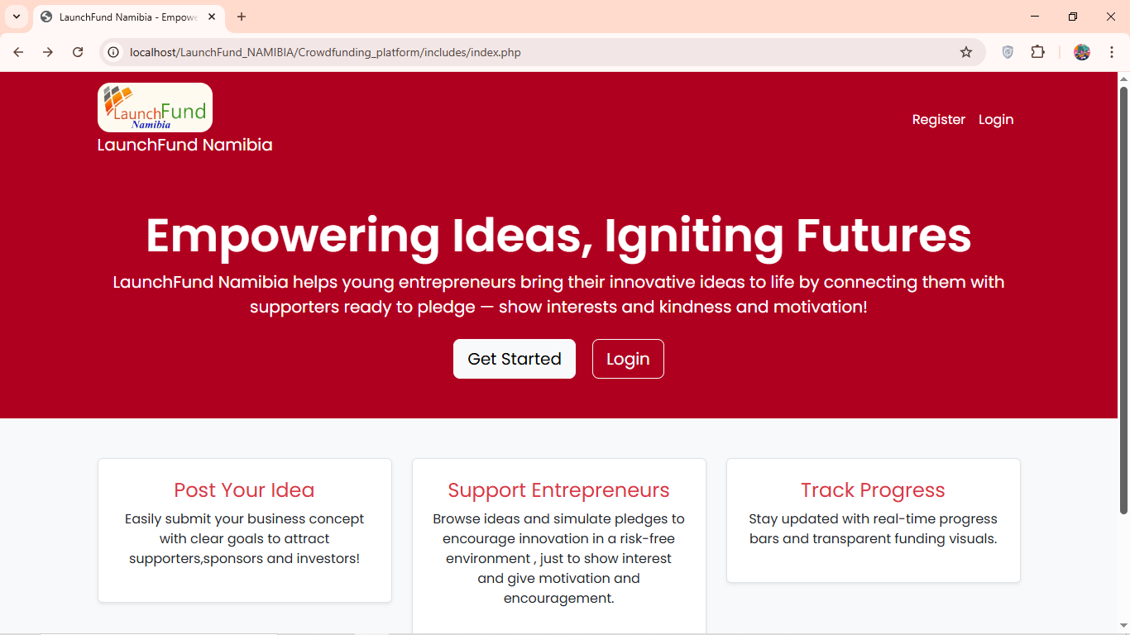

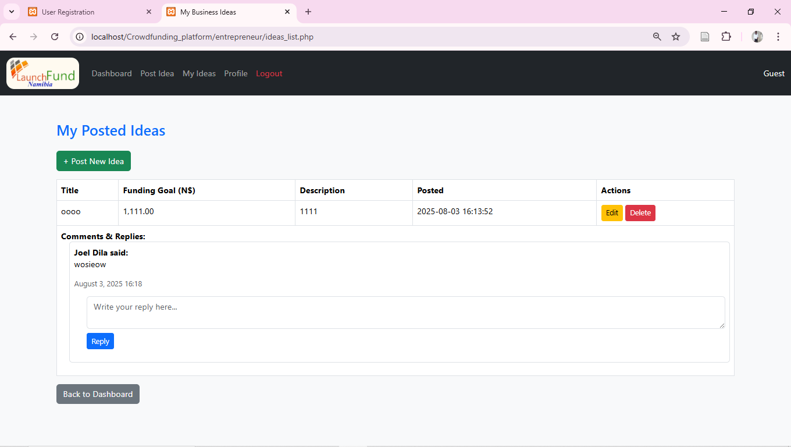

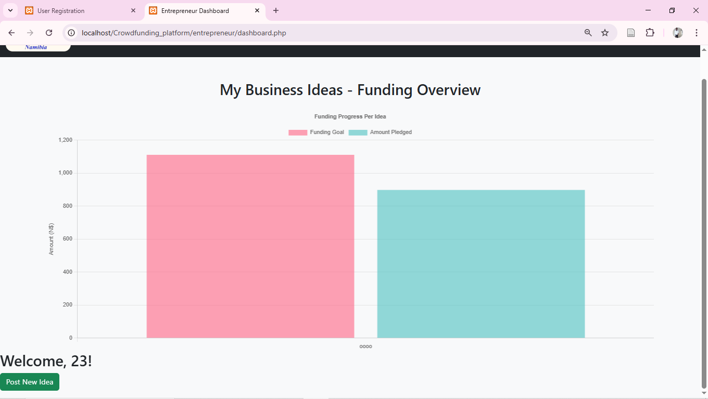

**Conclusion**

The Crowdfunding Namibia website is a space where great ideas meet the people who can help bring them to life. It gives entrepreneurs the chance to share their visions and connect with supporters who believe in their potential. By combining an easy-to-use design, smart backend processes, and reliable data management, the platform makes it simple for ideas to grow and for innovation to thrive in Namibia.